**Bhanoo P. Verma**

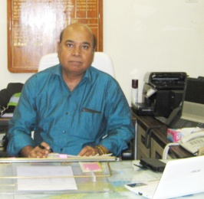

**Post Graduate Diploma in Management (MBA) from MANAGEMENT DEVELOPMENT INSTITUTE, GURGAON**

**Master of Engineering (Control and Instrumentation Engineering) from DELHI UNIVERSITY**

**Bachelor of Engineering (Electrical Engineering) from DELHI UNIVERSITY, INDIA**

Retired as **Chief Electrical Engineer (Higher Administrative Grade), Indian Railways**

Contact No. : +91 9868116068 E-Mail: [bpv.be.me.mba@gmail.com](mailto:engineerbverma@gmail.com) ; bpv_be_me_mba@yahoo.in

**SENIOR MANAGEMENT POSITION:- Overview:**

|  |  |  |
| --- | --- | --- |
| **Fields of Expertise** | | |
| * **Every position below covers Administration, Management and Engineering functions;** * Responsible for producing results; administering all related Management and Engineering fields and Interfaces- | | |
| **Highly professional experience of 35 Years in :**   * **Won Best performance shield for Elect. Engineering department at ‘National Level’** forLeading an organization spread over eight states, 4000Km Railway network, 522 Stations, 600 Engineers, 6000 workmen, 109 trains, 669 Elect Sub-Stations, 52000 buildings maintenance * **Secured Best Innovation award at Ministry of Railway’s level.** * **Top management of Railway Electrical systems** (i) Coach & MEMU manufacturing Factory (ii) Railway network operation of Electrical installations & Electrical systems on Trains on 2600 Km network, 2300 coaches including full AC trains, Generator Cars * **Electrical Engineering Design, Construction and Project Management** of 220Kv, 132kV Sub-Stations and Transmission Lines, 25Kv Railway Electric Traction System, SCADA system Railway Coaches Electrics & Air conditioning, 1000kVA Mobile Power Pack with Switchgear,11kV /415V Electric Supply Sub-Station, Electrical HT Cabling, Building Electrification, 132Kv/11Kv/415V Electric Supply for township & Workshop spread over 1200 Acre of land * **Mass Rapid Transit System: Design, Construction & Project Management** **of Electrical & Mechanical works** viz (1) Electrical Power distribution with Switchgear Panels and Cabling (2) Large DG Sets (MW) & UPS (3) Lighting (4) Large Air conditioning systems (5) Tunnel Ventilation (6) Fire detection & Fire suppression (7)Smoke Extraction (8) (Hydraulics) Water supply & Plumbing (9) Building Management System for all E&M Services * **Manufacturing and Production: Railway Carriage, Electric Multiple Units & Mobile power pack Manufacturing Factory** for Design of Electrical systems and system components , Equipment design and sizing; procurement of equipment with vendor evaluation; installation in coaches, commissioning and testing * **Operations and Maintenance Railway systems:** Electric Locomotives, Electric Multiple Units, Coaches, train formation and train sets; Diesel Generating Sets, 25 KV Electric Traction System, 220kV &132kV Sub Stations& Transmission lines, SCADA system, 132Kv/11kV /415V Electric Supply for Townships, Building Electrification | | |
| General Management | Engineering Management | Operations |
| Executive Leadership, Team Building, Strategic Planning, Project Management, Decision making & Effective communication, Infrastructure Management, Time Management, Budgeting , Planning, Quality Management, Safety Management**,** Training & Development , New Initiatives / Set-ups, Project Coordination | Design & Engineering Equipment Selection & Procurement , Vendor Management, Analysis & Problem Solving, Equipment Engineering, Contract Management, Resource deployment, Interface Management, Quality Management, Testing & Commissioning plan | Strategic Planning, Techno Commercial operations, Maintenance & Operations  Operations Safety, Contract Management, Interface Management, Resource Management- Manpower and Material, Time Management, Site Management |

**PERSONAL VITAE** Date of Birth : 6th April 1955

Nationality : Indian (Possess Valid Indian Passport)

Language Skill : English and Hindi

|  |
| --- |
| **OVERSEAS VISITS UNDERTAKEN** |
| * Singapore and Bangkok to study the Underground Metro systems. * Germany and Italy to study the High Speed Railway system, 2x25 Kv traction system and High speed train maintenance. * Completed one term of PG Management Diploma at Washington DC, USA |
| **PROFESSIONAL AFFILIATIONS** |
| * Life member of ‘ Institute of Urban Transport ( India ) ’ New Delhi * Life member of ‘Institution of Railway Electrical Engineers’ New Delhi * Presented paper on E&M services in ‘International seminar |
| **Computer skill**   * Good knowledge of Microsoft Words, Excel, Power Point but not efficient in regular typing. |

**Career Scan :**

|  |
| --- |
| **Manufacturing and Production: Top Management level: Railway Coach & Electric Multiple Units Manufacturing Plant (size 1600 coaches production per year, 8000 employees- Association at Senior Administrative Chief Engineer level (24 months)** |
| Electrical Design of AC (Air Conditioned) and Non AC coaches and 1000KVA Mobile Power pack, Electrical Multiple Units of 25KV AC, Defects Analysis and Design Up gradations, Production Coordination in Workshop, Electrical Operations & Maintenance of 132 KV/ 11KV & Low Voltage Electrical Supply Systems, Diesel Engine Generator 4x1 MW, Electrical Maintenance of 3700 Quarters & Township over 1200 Acres  **Few attainments: Commissioned 132/11kV sub station; Brought maintenance complaints to ZERO; Developed new design for coach lights and Elect. Panels; Control of a team of 1000 workers; Arranged material 100 items in time; Achieved production targets of coaches & EMU; Handled massive design & production coordination** |
| **Overall administration at Top Management level, Operation, maintenance, design, planning of Electrical installations & Equipments on Trains: Railway network (36 months)** |
| Overall Administration & Management over a network of 4000Km, 600 Engineers, 6000 workmen, 669 Electrical power 33KV, 11KV sub stations, LV Electrical systems at 600 stations, 10 KW Solar Panels, DA Sets upto 1250KVA; Electrical systems on 2300 coaches running upto 3500Km one way; Maintenance Operation and Massive coordination with many Railway & Non-Railway departments |
| **Mega Project: Underground Mass Rapid Transit System project (Delhi Metro) - Electrical and Mechanical Works- Association at Group General Manager & Chief Engineer level (85 months)** |
| **International Consortium** **of PCI+ JART+TONICHI (Japan), PBI (US), RITES India**.  **Controlling project functions** **from beginning till system commissioning** covering preliminary design, layout designs, tender specifications, contract finalisation, site supervision, Detailed design, contract management, quality and safety management. Interface management with other systems, vendor scrutiny and selection, equipment and system component specifications and selection, installation testing and commissioning for all Electrical and Mechanical  (E&M) systems on Delhi Metro for 6 nos. underground stations (with one passenger interchange station between two lines) and 7 km tunnel section.   * **The E&M systems included** * Tunnel ventilation, smoke control & extraction, air conditioning with chillers AHU & pumps, mechanical ventilation, * Electrical power supply systems with cabling, wiring & electrical distribution boards, * Electrical lighting, UPS, Diesel Generator sets, * fire detection & suppression for stations and tunnel (both water and gas based), * drainage, seepage and sewage system * Building Management control and monitoring system for all E&M systems   **Attainments:**   * Successfully completed E&M services to commission metro operations **8 months ahead of schedule, unique outcome in metro projects history. Devised new management concept of ‘shared access’ for achieving it and carried higher responsibilities of Coordination.** * **All works completed as per ‘Best International Standards’ of engineering, Quality and safety** |
| **Large Projects: Construction of 220KV, 132KV, 25KV Traction Distribution System (Over Railway track length of 1500 Km) at Senior Administrative Grade (Chief Engineer) and Jr SA Grade (Deputy Chief Engineer) level (48 months)** |
| Design, material management, coordination, installation & commissioning of Electrical works over a route length of 750 km. Project Planning, Detailed Engineering, Design, Techno- Commercial Functions, Budget Control, Contract and Site/ Safety Management for construction activities of:   * + 220kV, 132/25 kV Electrical substations & transmission line.   + Supervisory Remote control SCADA system.   + 25 kV Railway traction OHE works.   11 KV/ 440 volt substations, building electrification, cabling, wiring, |
| **Large Projects: Railway Electrification Project with 25KV system over 300 Km railway route, 750 Track Km at Jr Administrative Level (Deputy Chief Engineer) -72 months** |
| Design development, Project Planning, Detailed Engineering, Material planning, Contract management, Construction of 220 KV, 132KV Sub Stations and Transmission lines, 25KV Switching and Distribution posts, SCADA System for Remote control, Steel structures and Overhead Equipment installation, material management, coordination, installation & commissioning, Techno- Commercial Functions, Budget Control, Manpower management, Site & Safety Management |
| **Large Railway Projects: Gauge Conversion and Construction of New Lines (24months)** |
| Design development, Project Planning, Detailed Engineering, Material planning, Contract management for construction of 11kV electric sub-stations, overhead lines and underground cabling, Building Electrification wiring, lighting & electrical power supply, pumps, Interdepartmental interface |
| **Maintenance and Operations of 220KV, 132KV, 25KV Traction Distribution System (Over Railway track length of 1500 Km) at Senior Administrative Grade (Chief Engineer) level (12 months)** |
| Management of Maintenance and Operation of 25 KV Overhead Railway electrification Equipment, 132KV Sub-Stations, 132 KV Transmission Line, SCADA system, over a Railway route of 750 Km, Monitoring and ensuring Maintenance schedules, Enhancing reliability of equipments, Attending to breakdowns and failures, Administration of Organization on above railway route with manpower, Machines and tools, Maintenance Rail Cars etc. Attending to major breakdowns like derailments etc.  **Produced maintenance plan for critical ‘Rainy season’ enhanced operational efficiency by designing new sectioning and introducing innovative maintenance practices.** |
| **(1) Maintenance /operations of Railway Electric Locomotives, Loco holding of about 80 locos and operation over about 200 Km**  **(2) Maintenance /operations of Electric Multiple Units (EMU) with operation over 1200 Km**  **(34 months)** |
| (1) Spearheading scheduled maintenance works of electric locomotives in Maintenance workshop including Advance Planning for various maintenance schedules locowise, Workshop floor management, technical investigation of failures and unscheduled repairs, manpower deployment , Material planning and procurement initiation, Budget control  (2) **Established New Maintenance workshop for EMU (Electrical Multiple Units) maintenance,** Construction, Machine & plants commissioning, Manpower induction, Training to all maintenance & operations staff for New EMU maintenance practices, Devised maintenance schedules, Advance Planning of maintenance schedules, Workshop floor management, technical investigation of failures and unscheduled repairs, manpower deployment , Material planning and procurement initiation, Workshop and Running Maintenance, Crew Management, Supervision of Operations, Administration/ Manpower/ Material/ worksite/ Operations & Maintenance management. |
| **Maintenance/ operations of Railway Coaching Stock over a System spread over 2000 Km**  **(24 months)** |
| Administrating activities including planning & monitoring of maintenance and refurbishment of coaching stock, a holding of about 4500 nos. coaches, including 550 nos Air-conditioned coaches along with material & manpower management for most prestigious trains of Indian Railways.  Performing continuous technical and engineering analysis of abnormalities/ failures & evolving technical developments and up-gradations, Administration/ Manpower/ Material/ worksite/ Operations & Maintenance management.  **Effected conversion of coach air-conditioning system from distributed equipments to package system** |
| **PLANNING-12 months**  Planning for expansion of production workshop, maintenance workshops for electric locomotives, electrical multiple units, scope of work and cost estimation, preparation of drawings & plans, coordination for approvals, allotment of funds |
| **TRAINING- 6 months**  Administrative control of Electrical Training School imparting training to ‘maintenance and operation staff’ of Electrical power supply, Locomotives, Electrical Multiple Units covering Structuring of curriculum, syllabus, scheduling courses and classes, Developing model rooms and school, practical training in model rooms and on line, hostel, mess etc |

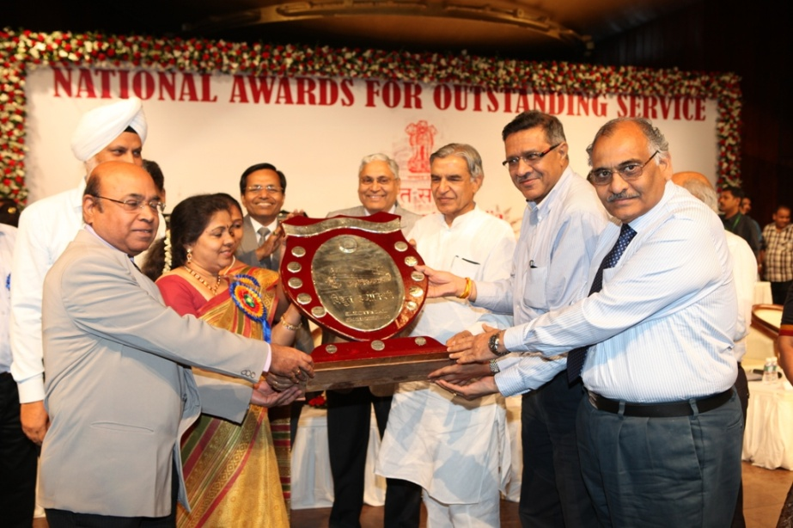

Receiving National award for Best performance of my Railway as Chief Electrical Engineer

***( For reference : Word document of PD/GC Appreciation letter)***

**PCI - PBI - JARTS - TONICHI - RITES**

**GENERAL** **CONSULTANTS FOR DELHI MRTS**

NBCC Place, 3rd Floor. Bhishmah Pitamah Marg, Pragati Vihar. New Delhi - 110 003

Fax: +91-11-2436-5846/5836 Phone: +91-11-2436-6216/6237

Date: 4th August. 2005

To Whom It May Concern

Mr B. P. Verma

Mr B. P. Verma is holding the position of Chief Resident Engineer (Electrical & Mechanical) for the General Consultants to the Delhi Metro Rail Corporation on the US$ 2.5 billion phase 1 Delhi Metro.

He reports directly to the Project Manager (Metro Corridor) and has been responsible for review and finalisation of ventilation and air-conditioning design together with the supervision of installation, testing and commissioning of all E&M systems in 6 of the underground stations.

Phase 1 of the Delhi Metro includes 3 lines, 2 elevated and one completely underground, totaling 62 km in length with 51 stations. The first section of Line 1 came into operation in December 2002 and as on date Lines 1 and 2 are fully operational carrying nearly 300,000 passengers *I* day. Line 3 is on schedule to be opened to the public in December 2005. Delhi Metro is a state-of-the-art, heavy rail metro capable of carrying 60,000 passenger per hour per direction. The underground stations are fully air-conditioned with smoke extraction, tunnel ventilation, building management, electrical and fire systems all of International standard.

Mr Verma has performed his duties with total commitment and enthusiasm taking particular care over safety and quality aspects and driving the contractor to achieve and indeed improve on, the required schedule. He has an extremely thorough understanding of railway technology in general and of electrical and mechanical systems for underground stations and metros. He has excellent communication skills conversing easily with contractors and consultants staff at all levels and is a good team member within our multi-national consortium.

In all his work activities Mr Verma has demonstrated a high degree of professionalism and integrity. His contribution to the success of Delhi Metro and the fact that the project was opened 8 months ahead of schedule has been immense and I would be delighted to have him as part of my team in any future project.

A. J. Burchell Project Director

General Consultants to Delhi MRTS